ICON PAINTING WORKSHOP WITH AIDAN HART

2019 September 9-13
at Walcot Hall, Lydbury North, Shropshire, SY7 8AZ

The teaching
This year, as in previous years, I shall be running a five day icon workshop in September 9-13, at beautiful Walcot Hall in Lydbury North, Shropshire (http://www.walcothall.com/). There will be no workshop in May.
We shall be painting a whole figure (standing or seated) and concentrate on garment painting. There will also be a talk with slides.
We all do the same icon, with Aidan guiding us through the different stages of building up colours in egg tempera on a previously prepared gessoed panel.
Participants bring their own pigments, panel and equipment. About three months before the course, students will be sent a list of materials that they will need to bring with them, along with instructions on how to make the gessoed panel. If desired, students can instead purchase a prepared panel. They will also be sent a digital copy of the icon that we shall be working on and will be expected to do a drawing of this before the workshop begins, so that we have maximum time for learning painting skills during the course itself.
The course consists of around seven hours tuition per day (9.00 am - 5.00 pm, except Monday when 10.30 am–5.00 pm, and Friday when 9.00 am -1.00 pm). There are places for twelve participants.

Transport
The nearest international airports are Birmingham International and Manchester. The nearest train station is Craven Arms, six miles from Walcot Hall. From there the best thing is a taxi (this needs to be booked in advance). Do a Google search for current taxi companies.

The cost
Since I became VAT registered eight years ago I have absorbed the VAT cost in order to keep the cost down for participants. I am no longer able to afford this, so will need to increase the cost to cover the VAT that I must pay the Revenue Department. The cost for the teaching will therefore be £444 (£370 plus 20% VAT).
The fee includes a substantial cooked lunch and morning and afternoon teas with biscuits and cakes.
A £30 deposit will be required y those whose registration is accepted. The non-refundable balance of £414 will due about three months before the course begins; an invoice will be mailed about two weeks before that due date.

Accommodation
The course offers self-catering accommodation at Walcot Hall to those who wish it. Participants are given their own bedroom in one of the Walcot apartments. Each apartment has two to three bedrooms and its own kitchen and bathroom or two. Accommodation is booked through the course and not directly with Walcot Hall.
The cost is £220 per person. This includes the bed linen and towels, and the food supplies for you to make your own breakfast. Participants will need to arrange their own evening meals. Bishops Castle is 3 miles (5 km) away and has numerous shops, takeaways and eating places.
A non-refundable £20 deposit is required of successful registrants.
The course accommodation is available from 9.30 am Monday until 1.00 pm Friday. Sometimes your room will be available at Walcot Hall for the Sunday night before the course (though not usually Friday night), but you will have to contact the office and arrange and pay for this extra night yourself directly (phone 01588 680570). Alternatively, If you need accommodation for Sunday or Friday nights, you can usually get rooms at the following local places:
- Brumslow Farm House Ph.01588 680244 Brumslow Farm
- Walcot Farm Ph. 01588 680243 https://www.booking.com/hotel/gb/walcot-farm.en-gb.html

Registration
If you wish to come, please fill in and return the registration form below (either by post or by email: mail@aidanharticons.com). Acceptance is on a first-come first-served basis, so only the senders of the first twelve registrants’ forms to be received can be accepted (places are usually filled within a few days). Successful registrants will then be sent an invoice for the deposits (£30 for tuition only, or £50 for tuition plus accommodation). These are non-refundable.

With best wishes,

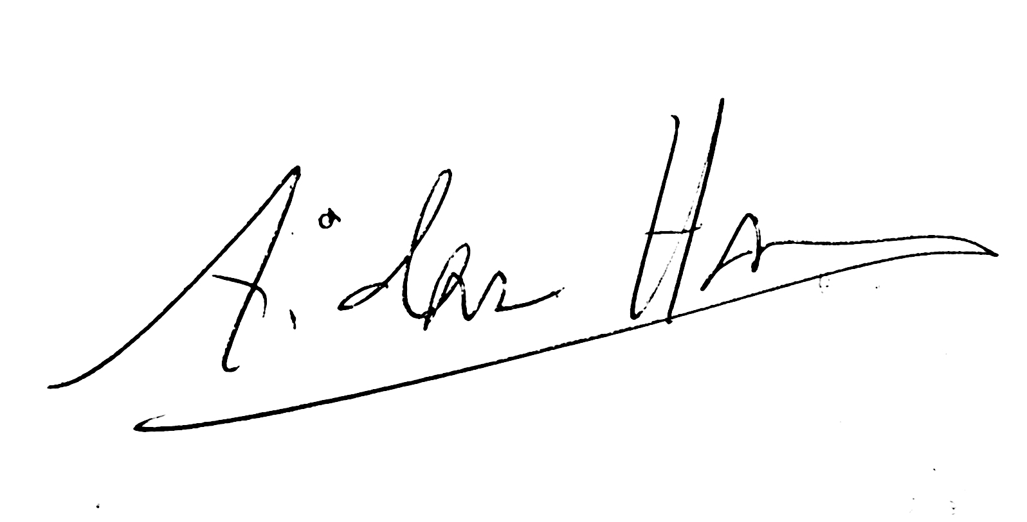

Aidan Hart

REGISTRATION FORM

FOR ICON WORKSHOPS WITH AIDAN HART
2019 September 9-13
at Walcot Hall, Lydbury North, Shropshire

NAME_______________________________________________

ADDRESS____________________________________________________________

_____________________________________________________________________

_____________________________________________________________________

PHONE NUMBER/MOBILE______________________________________

EMAIL_______________________________________________

SEPTEMBER 9-13
Yes, I would like to attend this course (tick here)----------------
Walcot accommodation required. Yes____ No____

MOBILITY NEEDS
Do you have mobility needs that require you to have a downstairs bedroom?
Yes____ No____

DIETARY REQUIREMENTS
Please indicate any dietary needs that you have. Please restrict these to necessary requirements (allergies) rather than preferences, as it is not possible to accommodate a big range of dietary requests:

_____________________________________________________________________

_____________________________________________________________________

Please fill in and return to Aidan:
EMAIL: mail@aidanharticons.com
POST: Aidan Hart, 94 Underdale Road, Shrewsbury, Shropshire, SY2 5EE, U.K.

For any queries contact Aidan at:

MOBILE: 07910 246774

EMAIL: mail@aidanharticons.com

