2023 ICON PAINTING WORKSHOPS WITH AIDAN HART
8-12 May and 18-22 September
at Walcot Hall, Lydbury North, Shropshire
(SatNav Powis Arms, Lydbury North, Shropshire)

The teaching
This year, 2023, as in previous years I shall be running a five-day icon workshop on May 8-12 and on September 18-22, at beautiful Walcot Hall in Lydbury North, Shropshire (SatNav SY7 8AU) (http://www.walcothall.com/).
In the May workshop we shall concentrate on the full figure (with an emphasis on proportion and drapery), and in September on the face and hands, so that icon will be a bust (waist up) or face. There will be a talk with slides at each workshop. The theology of the icon is taught in the context of learning the technique.
We all paint the same icon, with Aidan guiding us through the different stages of building up colours in traditional egg tempera on a previously prepared gessoed panel. After demonstrating each stage (there are about three demonstrations a day), Aidan spends time with each student one-to-one. Icon painting is a complex process and requires many years of training. The aim is not therefore to complete the icon by the end of the course, but to gain experience in the given area (drapery, or face and hands).
The course caters both for the inexperienced and the more experienced.
Participants bring their own pigments, panel and equipment. About three months before the course, students will be sent an invoice for the balance of payment and a list of materials that they will need to bring with them, including a prepared gesso panel. The panel can either be purchased, or if desired, students can make their own (instructions will be supplied). Students are sent a digital copy of the icon to be used as a prototype, and will be expected to do a drawing of this before the workshop begins. This is so that we have maximum time for learning painting skills during the course itself.
The course consists of around seven hours tuition per day (9.00am–5.00pm, except Monday when 10.00am–5.00pm, and Friday when 9.00am–1.00pm). There are places for twelve participants.

Transport
The nearest international airports are Birmingham International and Manchester. The nearest train station is Craven Arms, six miles from Walcot Hall. From there the best thing is a taxi (this needs to be booked in advance). Do a Google search for current taxi companies.

The cost
The cost for the teaching will be £490 (£408 plus 20% VAT).
The fee includes a substantial cooked lunch and morning and afternoon teas with biscuits and cakes.
A £30 deposit will be required by those whose registration is accepted. The non-refundable balance of £460 will be due about three months before the course begins. The invoice will be mailed about two weeks before that due date.

Accommodation
The course offers self-catering accommodation at Walcot Hall to those who wish it. Participants are given their own bedroom in one of the Walcot apartments. Each apartment has two to three bedrooms and its own kitchen and bathroom or two. Accommodation is booked through the course and not directly with Walcot Hall.
The accommodation cost is £250 per person (payable to Aidan Hart Icons, not to Walcot Hall). This includes bed linen and towels, and food supplies for you to make your own breakfast. Participants will need to arrange their own evening meals. Bishops Castle is 3 miles (5 km) away and has numerous shops, takeaways and eating places.
A non-refundable £20 deposit for accommodation is required of successful registrants.
The course accommodation is available from 9.30 am Monday until Friday morning, when rooms need to be emptied by 9.00am for the cleaners. Your room will often be available at Walcot Hall for the Sunday night before the course (though not usually Friday night), but you will have to contact the office and arrange and pay for this extra night yourself directly (phone 01588 680570 or email enquiries@walcothall.com). Alternatively, if you need accommodation for Sunday or Friday nights, you might be able to get rooms at the following local places:
- Brumslow Farm House Ph.01588 680244
- Walcot Farm Ph. 01588 680243 https://www.booking.com/hotel/gb/walcot-farm.en-gb.html

Registration
If you wish to come, please fill in and return the registration form below by email: mail@aidanharticons.com. Acceptance is on a first-come first-served basis, so only the senders of the first twelve registrants’ forms to be received can be accepted Places are usually filled within a short time, so don’t delay! Successful registrants will then be sent an invoice for the deposits (£30 for tuition only, or £50 for tuition plus accommodation). These are non-refundable.

With best wishes,

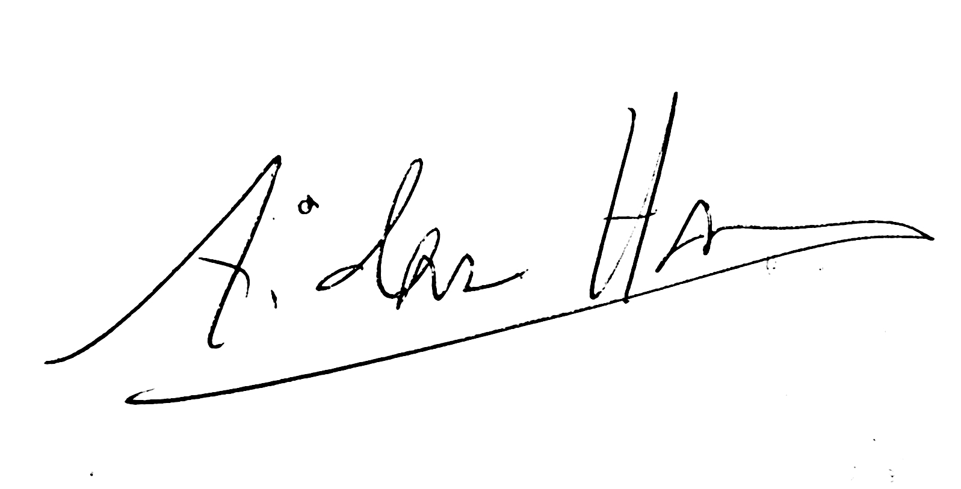

Aidan Hart

REGISTRATION FORM
FOR 2023 ICON WORKSHOPS WITH AIDAN HART
8-12 May and 18-22 September
at Walcot Hall, Lydbury North, Shropshire

NAME_______________________________________________

ADDRESS____________________________________________________________

_____________________________________________________________________

_____________________________________________________________________

PHONE NUMBER/MOBILE______________________________________

EMAIL_______________________________________________

8-12 MAY 2023
Yes, I would like to attend this course (tick here) ____
Walcot accommodation required. Yes____ No____

18-22 SEPTEMBER 2023
Yes, I would like to attend this course (tick here) ____
Walcot accommodation required. Yes____ No____

MOBILITY NEEDS
Do you have mobility needs that require you to have a downstairs bedroom?
Yes____ No____

DIETARY REQUIREMENTS
Please indicate any dietary needs that you have. Please restrict these to necessary requirements (allergies) rather than preferences, as it is not possible to accommodate a big range of dietary requests:

_____________________________________________________________________

_____________________________________________________________________

Please fill in and return to Aidan:
EMAIL: mail@aidanharticons.com
Applicants will be informed if a place is available or not, and receive an invoice for the deposit if so. Their place will be confirmed only on prompt receipt of payment.

For any queries contact Aidan at:

MOBILE: +44 (0)7910 246774

EMAIL: mail@aidanharticons.com

