2024 ICON PAINTING WORKSHOPS WITH AIDAN HART
20-24 May and 16-20 September
at Walcot Hall, Lydbury North, Shropshire
(SatNav: Powis Arms, Lydbury North, Shropshire)

The teaching
In 2024, as in previous years, I shall be running two five-day icon workshops at beautiful Walcot Hall in Lydbury North, Shropshire, SY7 8AU. (http://www.walcothall.com/). The dates are May 20-24 and September 16-20.
In the May workshop we shall concentrate on the face, so that icon will be a head or perhaps a bust, while September will be a full figure (with an emphasis on proportion and drapery). There will be a talk with slides at the beginning of each workshop. The theology of the icon is also taught throughout the week in the context of learning the technique.
We all paint the same icon, with Aidan guiding us through the different stages of building up colours in traditional egg tempera on a previously prepared gessoed panel. After demonstrating each stage (there are about three demonstrations a day), Aidan spends time with each student one-to-one. Icon painting is a complex process and requires many years of training. The aim is not therefore to complete the icon by the end of the course, but to gain experience in the given area (drapery, or face and hands).
The course caters both for the inexperienced and the more experienced, on a first-come-first serve basis.
Participants bring their own pigments, panel and equipment. About four months before the course, students will be sent an invoice for the balance of payment and a list of materials that they will need to bring with them, including a prepared gesso panel. The panel can either be purchased, or if desired, students can make their own (instructions will be supplied). Students are sent a digital copy of the icon to be used as a prototype, and will be expected to do a drawing of this before the workshop begins. This is so that we have maximum time for learning painting skills during the course itself.
The course consists of around seven hours tuition per day (9.00am–5.00pm, except Monday when 10.00am–5.00pm, and Friday when 9.00am–1.00pm). There are places for twelve participants.

Transport
The nearest international airports are Birmingham International and Manchester. The nearest train station is Craven Arms, six miles from Walcot Hall. From there the best thing is a taxi (this needs to be booked in advance). Do a Google search for current taxi companies.

The cost
The cost for the teaching, plus a substantial lunch and morning and afternoon teas, will be £550.
A £30 deposit will be required by those whose registration is accepted. The non-refundable balance of £520 will be due about four months before the course begins. The invoice will be mailed about two weeks before that due date.

Accommodation
The course offers self-catering accommodation at Walcot Hall to those who wish it. Participants are given their own bedroom in one of the Walcot apartments, now from Sunday evening until Friday morning. Each apartment has two to four bedrooms and its own kitchen and bathroom or two. Accommodation is booked through the course and not directly with Walcot Hall.
The accommodation cost is £335 per person (payable to Aidan Hart Icons, not to Walcot Hall). This increase from previous years is due not only to inflation but also to the fact that the admin at Walcot Hall now require me to book the apartments for Sunday evening as well as for the weekdays. Most people do in fact like to arrive the evening before, so this new arrangement is tidier for everyone.
This accommodation cost includes bed linen and towels, and food supplies for you to make your own breakfast. Participants will need to arrange their own evening meals. There is a fully equipped kitchen in each apartment, and Bishops Castle is 3 miles (5 km) away and has numerous shops, takeaways and eating places.
A non-refundable £20 deposit for accommodation is required of successful registrants.
The course accommodation is available from Sunday late afternoon (exact time to be confirmed) until Friday morning, when rooms need to be emptied by 9.00am for the cleaners.

Registration
If you wish to come, please fill in and return the registration form below by email: mail@aidanharticons.com. Acceptance is on a first-come first-served basis, so only the senders of the first twelve registrants’ forms to be received can be accepted Places are usually filled within a short time, so don’t delay! Successful registrants will then be sent an invoice for the deposits (£30 for tuition only, or £50 for tuition plus accommodation). These are non-refundable.

With best wishes,

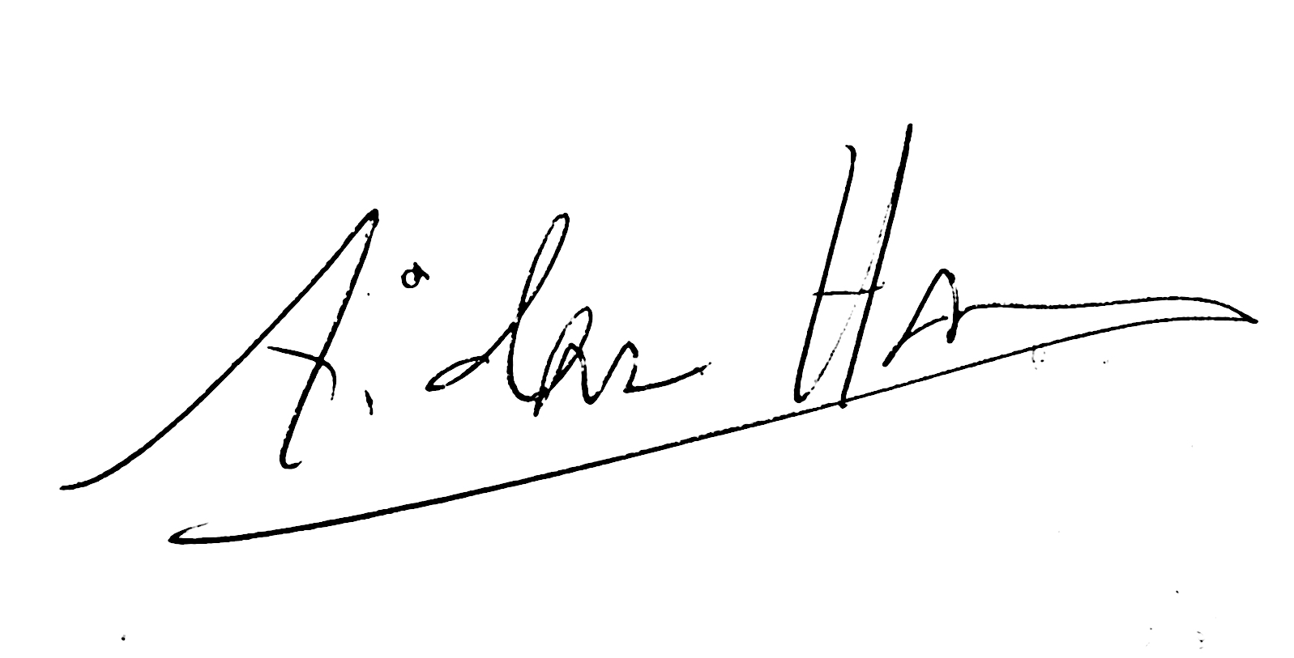

Aidan Hart

REGISTRATION FORM
FOR 2024 ICON WORKSHOPS WITH AIDAN HART
20-24 May and 16-20 September
at Walcot Hall, Lydbury North, Shropshire, UK

NAME_______________________________________________

ADDRESS____________________________________________________________

_____________________________________________________________________

_____________________________________________________________________

PHONE NUMBER/MOBILE______________________________________

EMAIL_______________________________________________

20-24 May 2024
Yes, I would like to attend this course (tick here) ____
Walcot accommodation required. Yes____ No____

16-20 SEPTEMBER 2024
Yes, I would like to attend this course (tick here) ____
Walcot accommodation required. Yes____ No____

MOBILITY NEEDS
Do you have mobility needs that require you to have a downstairs bedroom?
Yes____ No____

DIETARY REQUIREMENTS
Please indicate any dietary needs that you have. Please restrict these to necessary requirements (allergies) rather than preferences, as it is not possible to accommodate a big range of dietary requests:

_____________________________________________________________________

_____________________________________________________________________

Please fill in and return to Aidan:
EMAIL: mail@aidanharticons.com
Applicants will be informed if a place is available or not, and receive an invoice for the deposit if so. Their place will be confirmed only on prompt receipt of payment.

For any queries contact Aidan at:

MOBILE: +44 (0)7910 246774

EMAIL: mail@aidanharticons.com

